

Structural Design

(Inside View)

**Vertical corrugation**

Design#:

**LEAD EDGE**

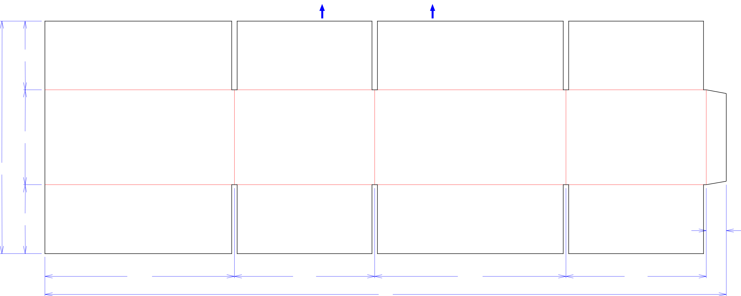

43*/*4

69*/*16

161*/*16

|  |  |  |  |  |
| --- | --- | --- | --- | --- |
| 43*/*4 |  |  | 13*/*8 |  |
|  |  |  |  |
| 131*/*16 | 911*/*16 | 133*/*16 | 911*/*16 |  |
|  |  | 47 |  |  |

**181227-01_A**

Customer:

**DeMet's Candy**

Description:

**E5898 / E5899 FLIPZ SNKMX 6.5oz Bag [Left-Hand 1/8" Gap] 9001557 9001559**

**SINGLE-OUT DRAWING**

Qty/Unit:

Style: **RSC**

Board: **32CK**

Combination: **35HP - 23M - 35HP**

I.D. : **13 x 9+1/2 x 6+1/4**

Area of Blank - Waste : **5.06 sq. ft.**

Waste on Blank : **3.43%**

Finished Piece Weight: **0.53 lbs./240.81g**

Over-all Blank: **16+1/16 x 47**

Notes:

Revision Info: **[A] 09/24/2018**

**AG**

Designer: **Alan Groff**

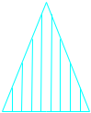

Cut Crease Crease with Matrix Cut Crease Half Knife Cut Tear Tape Perforation



Designright and Copyright of DS Smith Corrugated Packaging Ltd. This technical Specification is subject to Manufacturing tolerances. Drawing dimensions shown are crease to crease. Date printed: 09/24/2018